Student Name: VETHASURUTHI A
Register Number: 732925CSR170
Course Name: 25CST31 – Database Management Systems
Assignment Title: Assignment_3 - SQL Query Practice
Date of Assignment: 07.09.2026
Date of Submission: 11.09.2026

Employee Table
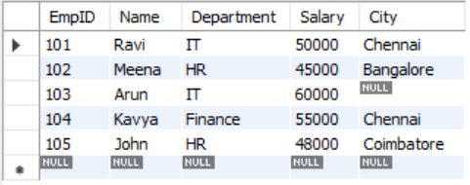
- Display all records from the Employee table
Query:
SELECT * FROM VETHA;
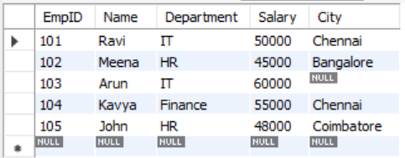

- Display only the Name and Salary of employee

Query:
SELECT Name, Salary FROM VETHA;
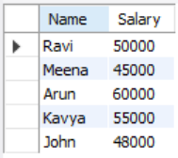

- Display employees whose salary is greater than 50,000
Query:
SELECT * FROM VETHA WHERE Salary > 50000;
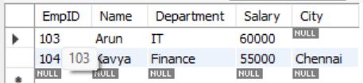
- Display employees who belong to the IT department
Query:
SELECT * FROM VETHA WHERE Department = 'IT';
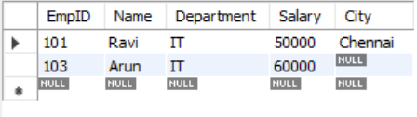
- Display employees whose city is Chennai
Query:
SELECT * FROM VETHA WHERE City = 'Chennai';
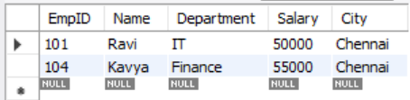
6. Display employees whose salary is between 40,000 and 60,000
Query:
SELECT * FROM VETHA WHERE Salary BETWEEN 40000 AND 60000;
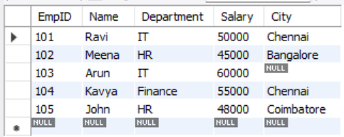
7.Display employee names that start with 'A' using LIKE
Query:
SELECT Name FROM VETHA WHERE Name LIKE 'A%';
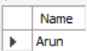
8. Display distinct departments
Query:
SELECT DISTINCT Department FROM VETHA;
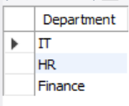
9. Display employees whose City value is NULL
Query:
SELECT * FROM VETHA WHERE City IS NULL;
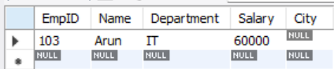
10. Find the total salary paid to all employees
Query:
SELECT SUM(Salary) AS Total_Salary FROM VETHA;
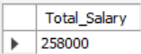
11. Find the average salary of employees in the IT department
Query:
SELECT AVG(Salary) AS Average_Salary FROM VETHA WHERE Department = 'IT';
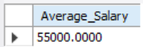
12. Count the number of employees in each department using GROUP BY
Query:
SELECT Department, COUNT(*) AS VETHA Count FROM VETHA GROUP BY Department;
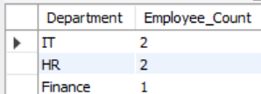
13. Display employees whose salary is greater than the average salary
Query:
SELECT * FROM VETHA WHERE Salary > (SELECT AVG(Salary) FROM VETHA);
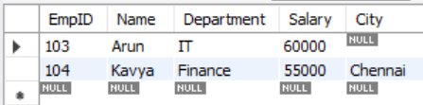
14. Insert a new employee record
Query:
INSERT INTO VETHA (EmpID, Name, Department, Salary, City) VALUES (106, 'Priya', 'IT', 52000, 'Chennai');

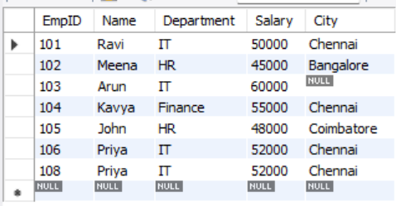
15. Update the salary of EmpID 105 to 48000
Query:
UPDATE VETHA SET Salary = 48000 WHERE EmpID = 105;
